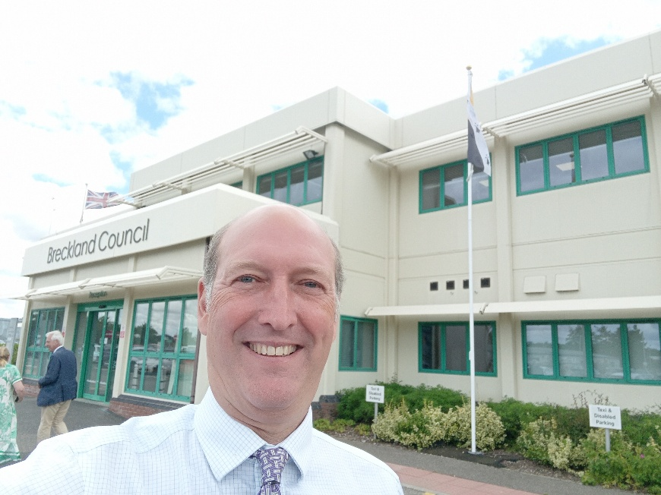

Cllr BILL BORRETT
Parish report for the Upper Wensum Ward
October 2026

“BRECKLAND LIVES”
Thanks to the shambles in Westminster the Government has “paused” Local Government Reorganisation (LGR) for the time being.
Why is this something I would be interested in?
Well, it means that your Council Tax won’t be going up by 30% next spring. Breckland is still the LOWEST District Council Tax in England, and we will not be taking on any debts from other Councils or sharing our reserves with them.
Why is the Council tax so low?
Breckland raises money by lending money to other Councils and uses the interest to keep Council Tax down, it also manages a portfolio of Commercial Property that provides nearly as much income as Council Tax raises. These didn’t happen by accident but are the result of sensible decisions going back to 1999 when the Conservatives took over a very poor performing Breckland Council from Labour.
Why aren’t all Councils run this way?
The simple answer is I don’t know, it is up to the elected Members.

Planning
The Government’s new “National Scheme of Delegation” comes into force on 31st October.
This will significantly reduce the role of Councillors in determining planning applications. It removes the ability of a Local Member to “call in” applications, removing Planning Committees ability to decide planning applications of 10 dwellings or less, requiring a Council Officer to give permission to the Planning Committee to sit on an application of more than 10 dwellings and giving Angela Rayner call in powers when applications of over 150 dwellings are refused.
This centralises decision making and removes the local democratic element that has been a cornerstone of Planning Policy since 1948.

Community Grants
There are TWO different opportunities for Parish Councils and Community Groups to apply for GRANTS from Breckland.
The first opportunity is only open until 15th October so please pass this on straight away: BRECKLAND COUNCIL INSPIRING COMMUNITIES GRANT
We are looking for projects that make a real difference in Local Communities by improving health and wellbeing, reducing loneliness and isolation, supporting vulnerable residents and encouraging community involvement.
Up to £5000.00 is available and it is no longer necessary to raise any match funding.
If you are interested please go to the Norfolk Community Foundation website and search for “Breckland Council Inspiring Communities Grant”.
The other option is the “COMMUNITY SMALL GRANT FUND” which has grants of up to £250.00 for activities during the October and February half term holidays.
Parish Council’s, schools and local community groups (including sports clubs) can apply for grants to put on activities to involve their local communities covering everything from family fun days to gardening!
The full details are available on the Breckland Council Web site under the heading “Community Small Grant Fund”.

Food Waste Collections
This has now begun. It is a weekly collection that happens on the same day as you normal bin collection. I have had a few initial queries regarding bins etc. but I am very glad to report that most of them are now sorted and the service is getting bedded in.

Solar Farms
Beckland’s policy on Solar Farms remains consistent and I just wanted to remind everyone what it is should you get any applications in your area.
“Solar generation in the district should be directed towards existing buildings, rooftops, brownfield land rather than productive agricultural land”.

Devolution
Despite the turmoil on Local Government Reorganisation (LGR) there is news that the Government’s plans on Devolution might be re-started by the Reform lead County Councils in Norfolk and Suffolk. If they both tell the Government that they want a joint Mayor for Norfolk and Suffolk, then there is likely to be an election for one in 2028. We will then start to get charged for the new Combined Authority, which the Mayor will run, soon afterwards.
I understand that there will be meetings in both Norfolk and Suffolk County Councils this October to decide. Watch this space!

Thank you for reading this, as always please do not hesitate to contact me if you have any questions.
My email address is: bill.borrett@breckland.gov.uk
With my best wishes

Bill
BILL BORRETT
Member for the Upper Wensum Ward
Breckland District Council

