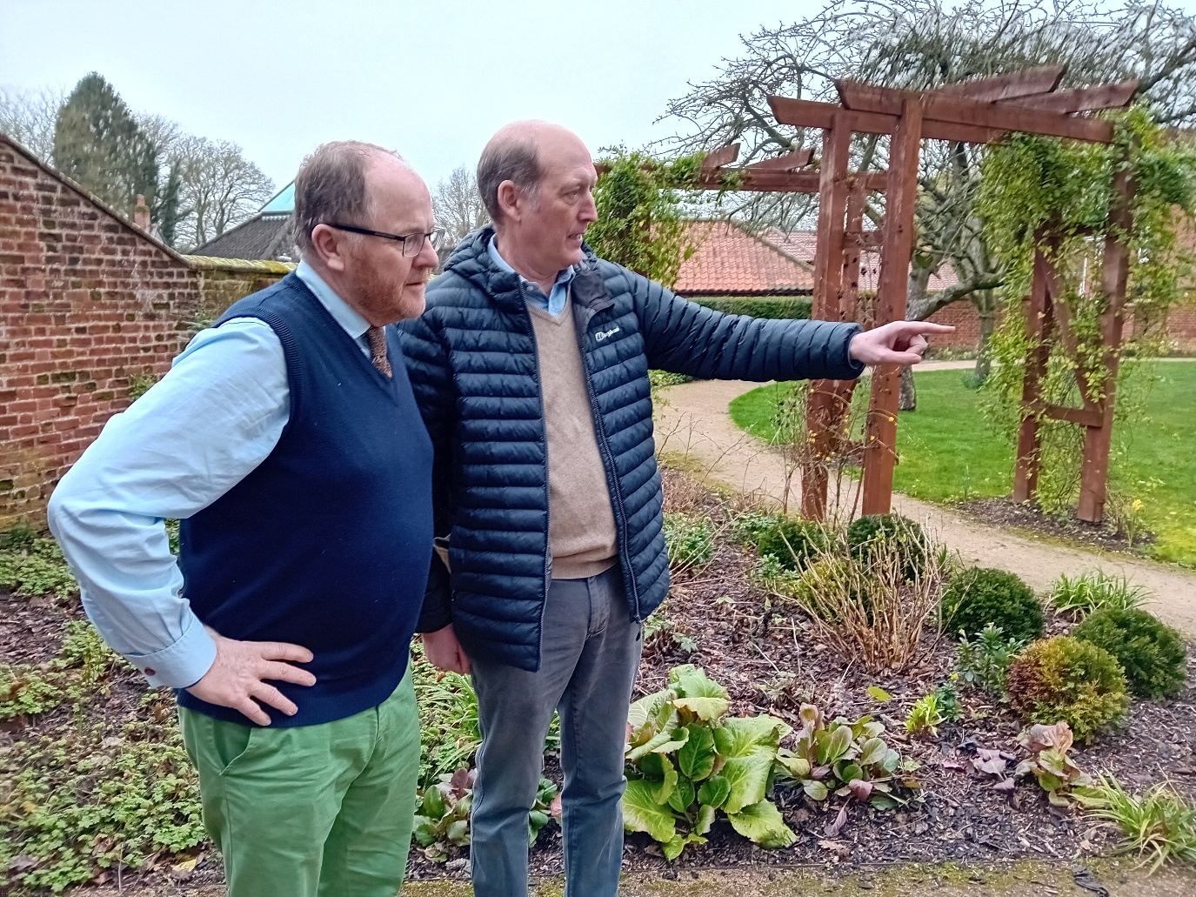
Working together with George Freeman
Cllr BILL BORRETT
Parish Report for the Elmham and Mattishall Division
April/May 2026
Breckland and Norfolk County Council to be abolished in 2028
The Government have finally announced what they have been threatening for a long time, Norfolk County Council and Breckland Council are going. It is planned that they will be replaced by a new Unitary Council for West Norfolk (if the Government doesn’t change its mind).
Whilst this is the “least worse” option that was on the table, it is very likely to mean an increase in the Council tax for Breckland Residents for no corresponding increase in services. This is because Breckland has the lowest Council Tax out of all Norfolk’s District Councils and any amalgamation of Councils will mean a levelling out of the Council Tax, which is very unlikely to be to the lowest!
There is also likely going to be years of change as the new Councils grapple with multiple systems whilst all the time continuing to have to deliver your services. Looking at where this has happened elsewhere in the country, it has taken many years. At least we are not going in with Norwich City Council which has an extremely high Council Tax and very large debts for a Council of its size.
Local Government Elections on May 7th
I campaigned hard for the Elections, which had already been postponed once, to go ahead on 7th May, even standing down from the Cabinet at the County Council in order to speak freely on your behalf.
That being said, I am now out campaigning to be re-elected as your County Councillor, depending on the outcome of the vote on 7th May this may be my last Parish Report so there are a couple of things I would like to say.
Most importantly, thank you very much for all your support since I was first elected in 2009. I have had an opportunity to meet and get to know so many interesting people, many of whom give up large amounts of their time to help make their communities a better place.
It has been a privilege to fight for our villages at the County Council, which is a huge organisation, making sure that we are not forgotten and that the services it provides are “fit for purpose” and affordable.
In my opinion There has been very little common sense in much of Government in recent years and the wisdom of local residents is often not heard by those in power. I have made it my business to make sure that as much of it as possible is heard by Government, be it a Local or National level.
A Quick recap of some of the things that we have been able to get done:
Our Promises | What Was Delivered | Impact
Libraries & Culture | Built new libraries, invested £3m+, and transformed Norwich Castle into a world-class attraction with the help of the National Lottery. | Stronger cultural offer and a major boost for tourism
Better Care | Invested £40m+ in care homes and supported living, to increase quality and choice for residents. | More residents able to live independently for longer
Backing Our Children | GOOD-rated services, £2.5m+ for care leavers, £5m for jobs, and 600+ opportunities created | Better life chances and stronger futures for young people
Investment in Roads | Major infrastructure projects completed and £10m extra invested in maintenance for our six thousand miles of roads. | One of the best-performing highways services in the country
Improved Buses | £50m+ invested, more rural busses giving a 26% growth in passenger numbers | Better public transport access for rural areas
Protecting the Environment | 850,000+ trees planted and C02 emissions cut by 50% | Protecting Norfolk’s countryside and tackling climate change
Growing the Economy | Investment in our high streets, improved connectivity. | Stronger local economy and thriving communities

Norfolk County Council, under a Conservative administration, has a strong record of delivering on its promises and investing in the county’s future. From new libraries and major road schemes to over £40 million in care and significant improvements in children’s services, we have focused on the priorities that matter most to residents. We have strengthened local transport, supported businesses and high streets, expanded opportunities for young people, and taken meaningful action to protect Norfolk’s environment. This is a council that combines experience with action backing communities, improving services, and driving sustainable growth, while continuing to stand up for Norfolk and secure the investment it deserves.
Norfolk County Council Approved £500k Community Fund to Boost Local Projects
A reminder that Norfolk County Council approved the launch of a new £500k Norfolk Community Fund for 2025/26, aimed at supporting grassroots projects that strengthen communities and improve local wellbeing.
The fund will empower local voluntary, community, and social enterprise (VCSE) groups to apply for grants between £200 and £2,500 to deliver small-scale initiatives that bring people together, promote inclusion, and enhance quality of life. Each of the county’s 84 councillors will be allocated £5,000 to distribute within their divisions, ensuring funding reaches every corner of Norfolk
Norfolk County Council delivered a balanced and responsible budget for 2026–27
Norfolk County Council approved a balanced £613.8m budget for 2026–27, demonstrating strong financial leadership and prudent management in what remains one of the toughest funding climates in decades.
We have been able to once again deliver stability and certainty for residents, setting a balanced financial position while identifying £42.3 million in savings and efficiencies and committing £76.3 million in targeted investment to protect vital services and strengthen Norfolk’s economy.
Despite significant national financial pressures and ongoing constraints in central government funding, we have ensured the county remains on a firm financial footing, without resorting to emergency measures. This stands in stark contrast to a growing number of upper-tier authorities across the country that have issued Section 114 notices or are facing effective bankruptcy.
The budget enables the council to continue:
- Protecting frontline services
- Investing heavily in adults and children’s services
- Delivering new libraries and modern learning hubs in key towns
- Supporting for heritage, culture, and tourism
- Driving transformative reforms to improve efficiency and outcomes
- Backing economic growth and infrastructure
- Maintaining long-term financially sustainability
In line with national funding assumptions a 4.998% increase in council tax was implemented due to the government’s continued reliance on placing the burden on local taxpayers to safeguard core services. This decision reflects the financial realities facing councils nationwide, while ensuring essential services remain protected for Norfolk residents.
This budget reinforces Norfolk’s Conservative administration’s commitment to careful stewardship of taxpayers’ money, strong local services, and a resilient future for the county.
An Example how we have been working to change the way the Council does things to better support residents: Our Nationally recognised ‘AI’ programme to prevent falls
A new, nationally recognised proactive intervention scheme is rolled out across the whole of Norfolk. The initiative was delivered in collaboration with local partners including Voluntary, Community and Social Enterprises (VCSE), city, district and borough Councils and NHS organisations, aims to reduce falls in vulnerable and older adults.
Following a successful pilot with 1250 residents, the programme, which uses Artificial Intelligence (AI) to identify residents at risk of escalating needs, enhances the safety and wellbeing of those at risk of falls. The latest Artificial Intelligence technology, natural language processing is used to 'read' case notes and automatically extract meaningful insight about our residents. This technology enables the council to identify and prioritise individuals in Norfolk most at risk of falling, allows for proactive intervention before they fall.
AI is a rapidly developing technology with the potential to improve the delivery of services. The council is using AI to benefit the people of Norfolk in a safe, ethical and transparent way.
Falls are a major concern, particularly among older or vulnerable adults, and can lead to severe injuries and a decline in quality of life. Through this programme, the council will be able to predict people who are at higher risk and offer timely and targeted interventions to support them.
For more information about preventing falls visit Preventing and dealing with falls.
Once again, thank you all for your support, it has been a pleasure representing your village and I wish you all the very best in the future.
If you have any queries please do not hesitate to contact me on bill.borrett@norfolk.gov.uk
With my best wishes
Bill
BILL BORRETT

